Term 1 2022
1x Form per dancer

REGISTRATION FORM

7th Feb– 15th April
Dancers Name: |  | Age:
Postal Address: | Email: (Important)
Phone number- Home: ( ) | Mobile Number: (Important)

CLASS TYPE: (please CIRCLE appropriate box)

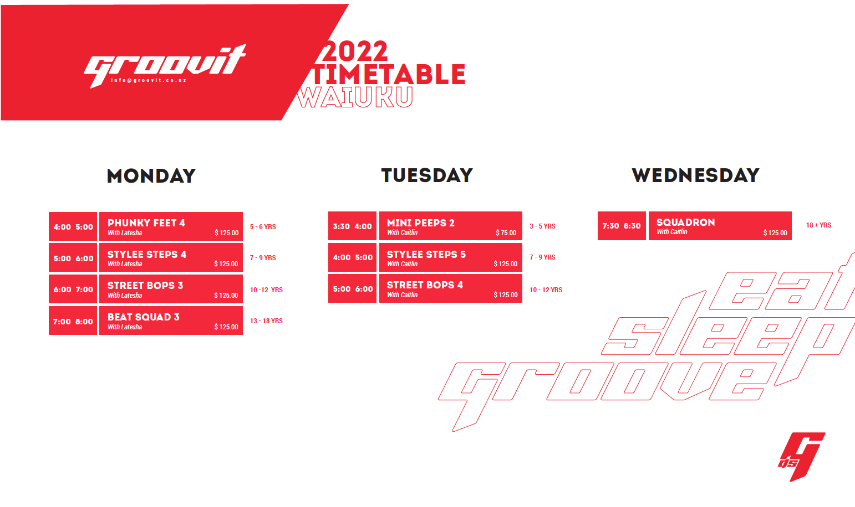

We have a two week “No Obligation” policy, where new dancers can register at the start of a term to give it a go. After this time dancers will be charged for the full term. Everyone must register, even if you are just having a go. We often have a waiting list, so please inform Groovit if a dancer is not returning. Once a dancer has registered & paid fees, there are NO REFUNDS given to dancers who change their mind or miss lessons.

NOTE: In order to receive the ’20% Prompt Payment Discount’ all fees must be paid in full by the 4th of March

If fees are outstanding any debt recovery charges incurred will be payable by the Debtor.

Please tick this box if you would prefer that you or your dancers photo or video was NOT used on GROOVIT’s Facebook page or any other form of advertising

PAYMENT
 | DIRECT CREDIT |  | CHEQUE  Made Payable to Groovit |  | CASH | AMOUNT PAID $ | Date Paid

Direct Credit Details: Groovit ASB 12-3052-0012963-00

Particulars: Account holders name Code: Dancers Name Reference: Class name

By signing this form I accept full responsibility for any injury or sickness that may occur while participating in classes and agree that ‘groovit’ and/or its instructors are not liable financially or otherwise. I have read and filled out the above form with accuracy and honesty.
I have made the instructor aware of any serious conditions or illnesses and have completed a 2021 Health & Medical Form
All Choreography, Dance Routines, CD’s and Music Mixes are the intellectual property of Groovit and are not for public use.
PTO

Parents Name:
 | Dancers or Parents Signature: | Date:

HEALTH & MEDICAL FORM 2022
(NOTE: This form only needs to be filled out once a year, unless changes need to be made)

Dancers Name: | Age:

Do you suffer from any of the following:
Asthma: |  | Diabetes: |  | Epilepsy:

Do you have any other medical conditions that may affect your ability to exercise? | YES |  | NO
If yes please describe below:

Have you had any injuries, pains or procedures that may affect your ability to exercise? Please state where.  (I.e. Sprains, brakes, dislocations, cuts, operations etc.)? | YES |  | NO
If yes please describe below:

Does this Dancer have a vaccine passport? If so, please show reception.

Emergency contact name: | Contact Phone Number:

Signed: | Date:
If under the age of 18 years old a parent or guardian must sign this form on your behalf.

By signing this form, I (signatory) accept full responsibility for any injury or sickness that may occur while participating in classes and agree that ‘groovit’ and/or its instructors/choreographers are not liable financially or otherwise.
I have read and filled out the above form with accuracy and honesty.
I have made groovit aware of any serious conditions, pains or any other type of injuries that may affect my ability to dance.

All the information that has been obtained on this form will remain confidential.

